table_css_1(11-2018).html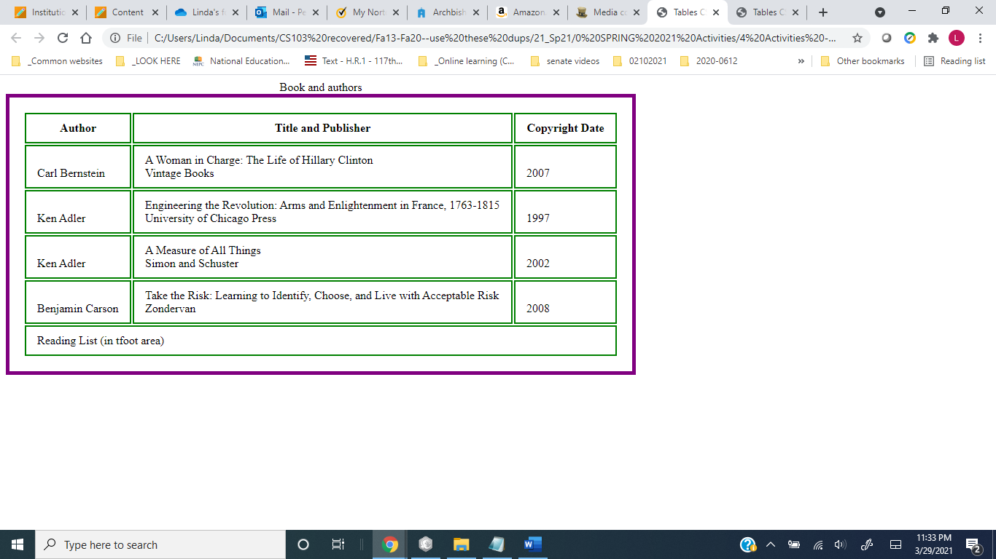

green border

purple border

table_css_2(11-2018).html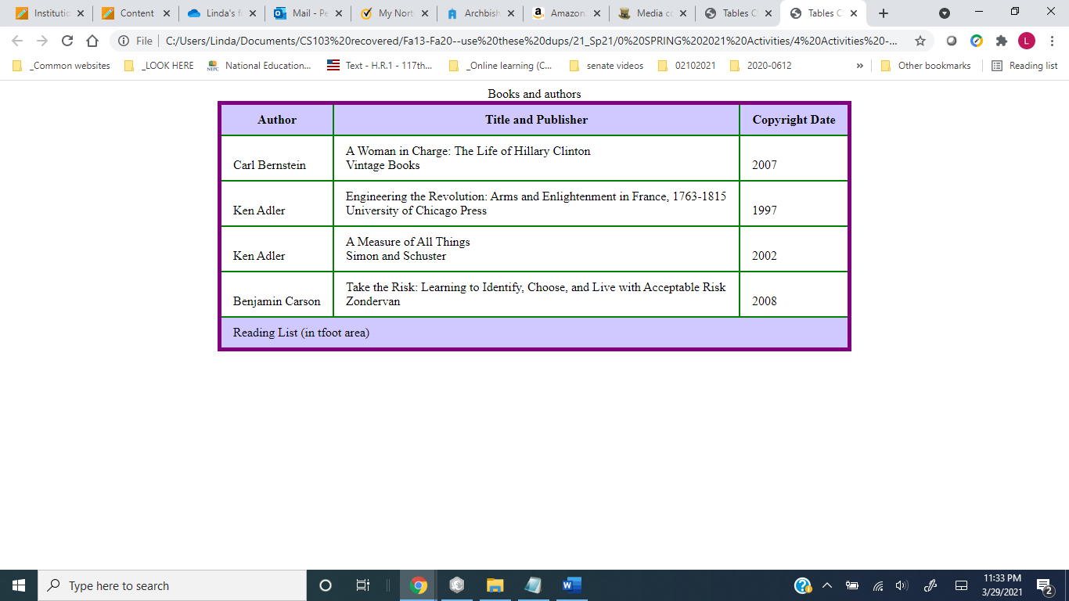

green border

purple border

The second table is the first table, with more styles added to it.

The addition of the style rule:

**table {border-collapse: collapse}**

is what makes the borders *collapse* and appear as they do in the second table.